Assignment – I (10%)

COMP 3123 – Full Stack Development – I

Submission: Sunday, 13th Oct 2024, 11:59 PM (Week06)

# SCREENSHOTS FOR POSTMAN

User Management:

POST /api/v1/user/signup 201 Allow user to create new account

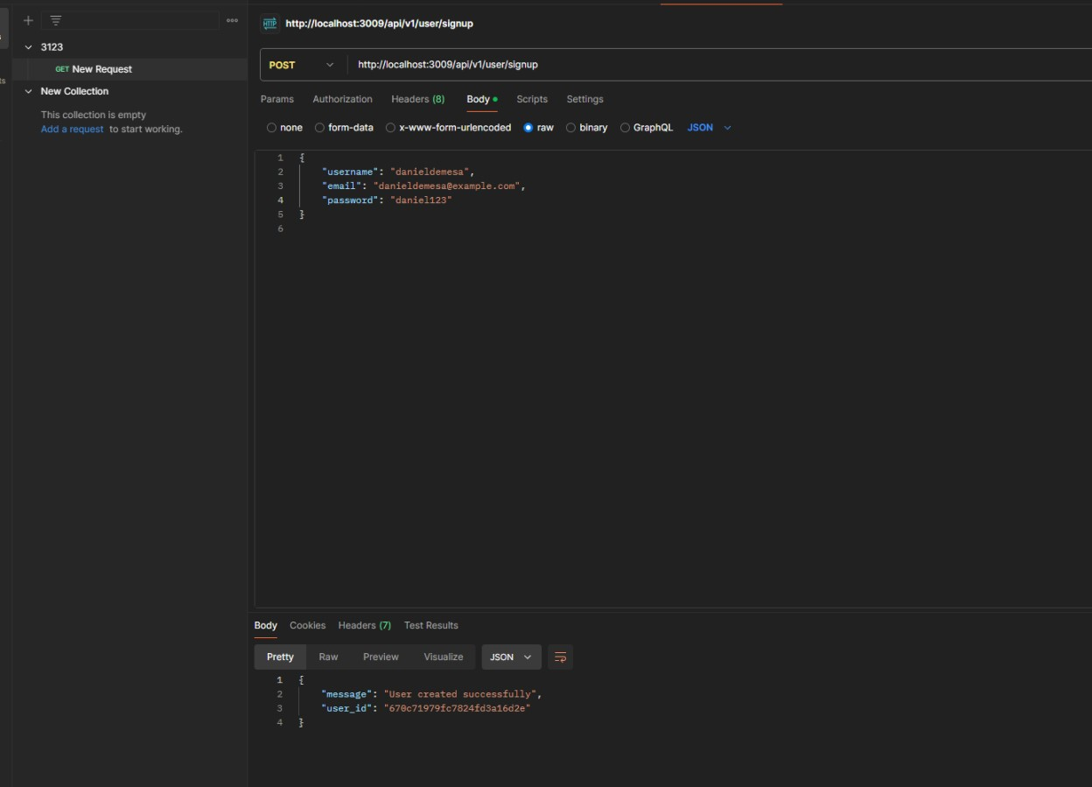

POST /api/v1/user/login 200 Allow user to access the system Employee Management:

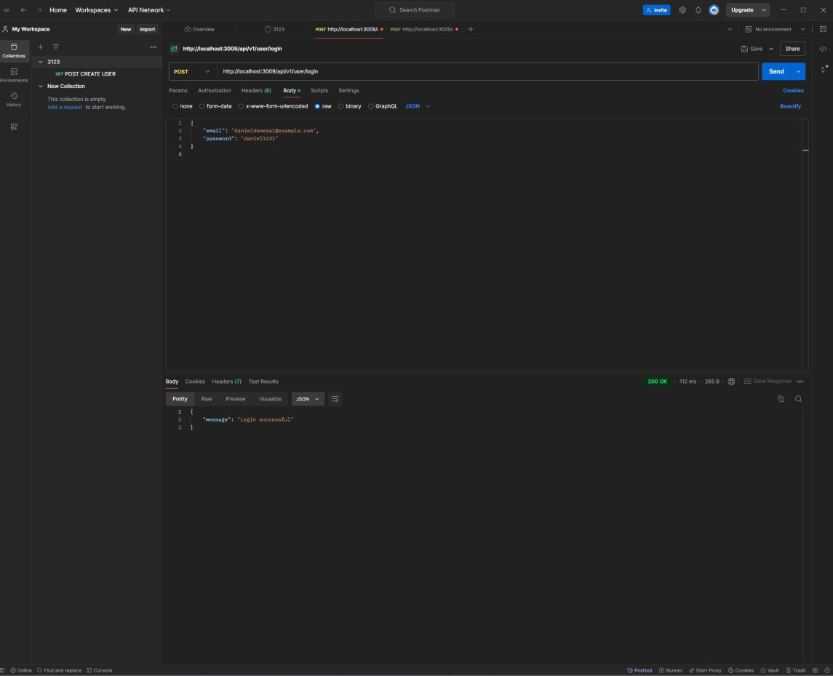

POST /api/v1/emp/employees 201 User can create new employee

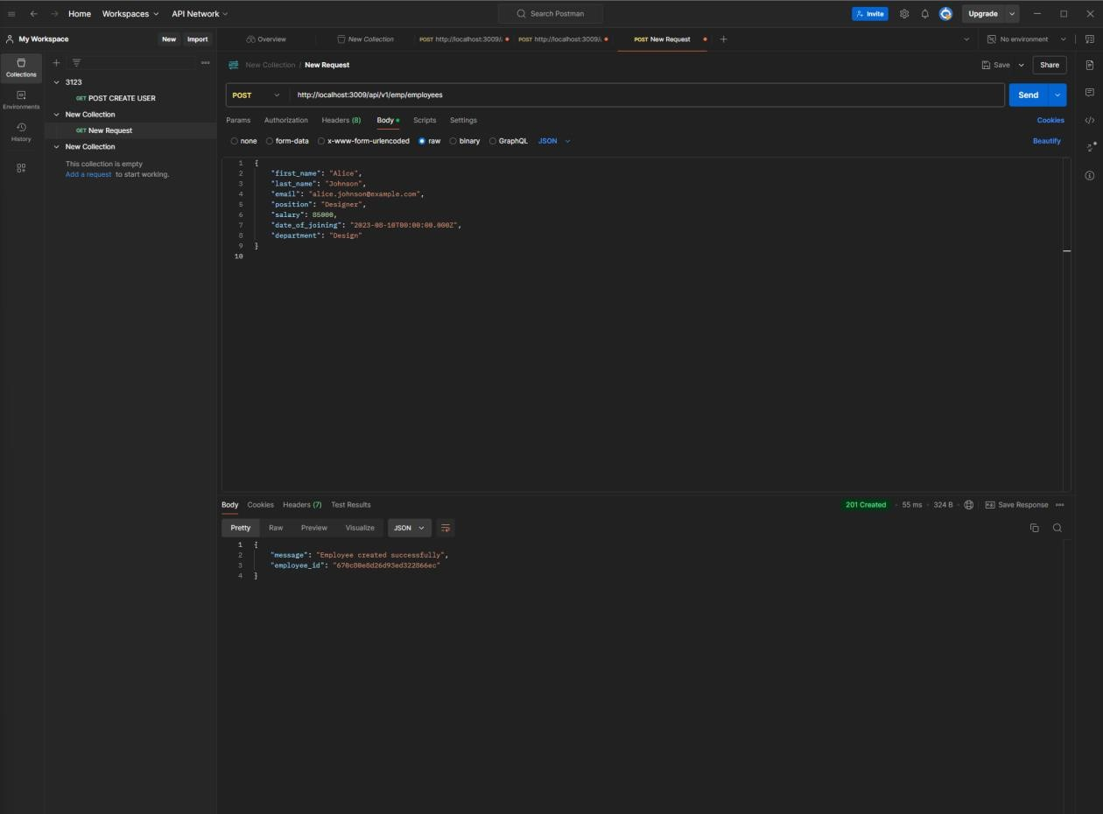

GET /api/v1/emp/employees/{eid} 200 User can get employee details by employee id

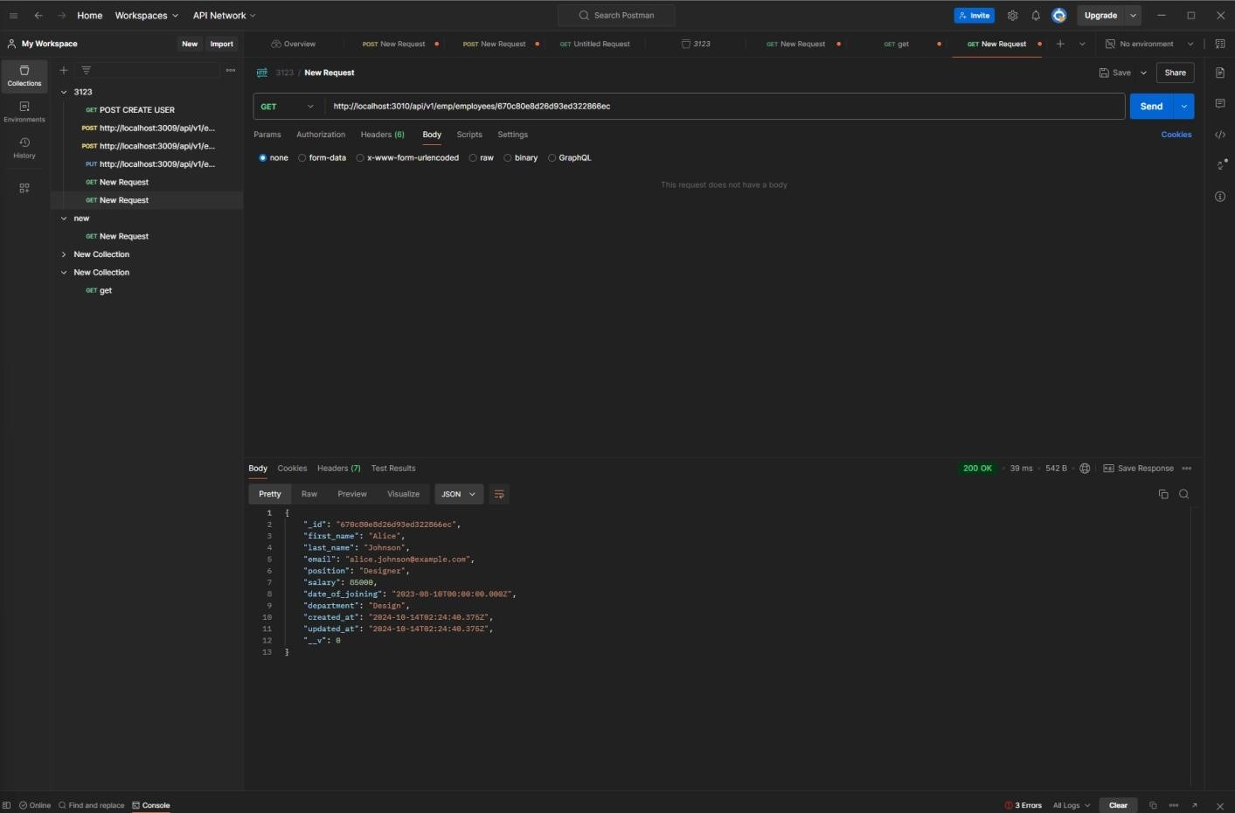

PUT /api/v1/emp/employees/{eid} 200 User can update employee details

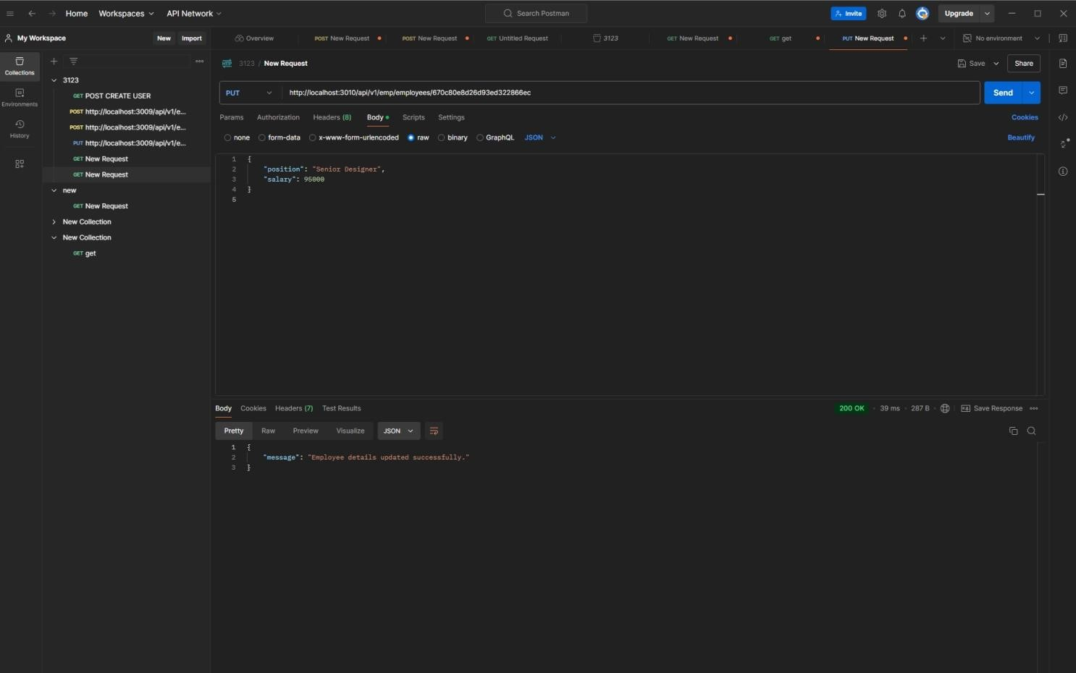

DELETE /api/v1/emp/employees?eid=xxx 204 User can delete employee by employee id

